學校圖書館

School Library

在這個專案中，你會做出一個能推薦書籍的圖書館管理員。

In this project you will make a school librarian character that can make reading book recommendations.

當你向管理員描述一本書的時候，電腦會預測誰適合讀這本書。

If you describe a book to it, it will try to predict who that book might be suitable for.

你會給電腦一些小說範例，訓練電腦辨別不同難度的小說。

You will teach the computer to recognise fiction books of different reading levels by giving it examples of each.

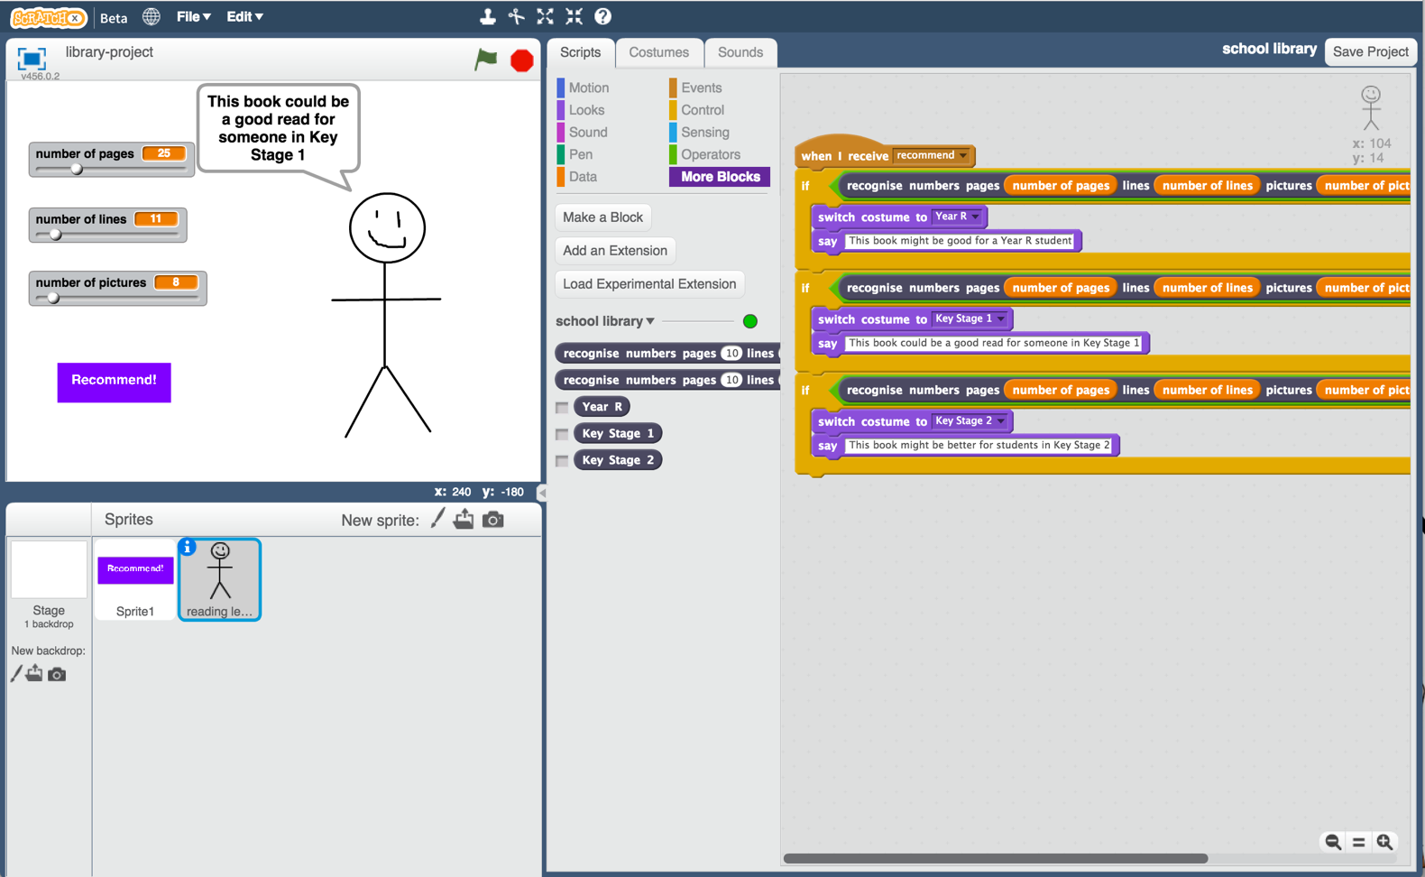

This project worksheet is licensed under a Creative Commons Attribution Non-Commercial Share-Alike License

http://creativecommons.org/licenses/by-nc-sa/4.0/

1. 為了順利進行這個專案，你需要一些小說，去學校圖書館找找吧！

You need a collection of fiction books for this project.   
Go to the school library!

1. 蒐集不同難度的小說，並紀錄每本書的以下資訊：

*總頁數

*每頁行數（選擇整頁都是文字的那頁做紀錄）

*圖片總數量（如果書很厚，或者圖片真的太多，可以用估算的數字）

*難度等級（例如：簡單、中等、困難）

*你的學校可能會用難度或不同顏色標籤的方式分類書本，盡量只選擇當中的幾種，不要選太多類別。*

Find examples of fiction books of different reading levels, and collect the following information about them:  
* Number of pages in the book  
* Number of lines in each page (*choose a typical full page of text*)  
* Number of pictures in the book (*if the book is too long, or there are too many pictures to count, it’s okay to make an estimate*)  
* The reading level (e.g. Year R / Key Stage 1 / Key Stage 2.   
*Your school may have different ways to group fiction books, such as by reading level or using coloured bands. Try to limit yourself to just a few different reading levels though*)

1. 每個難度級別都至少選五本書，依照下面的表格紀錄每本書的總頁數、每頁行數以及圖片數。

*如果能記錄更多書會更好！*

*拿張紙跟筆，畫出下面的表格，這樣可以幫助你做紀錄。*

Do this for at least five books at each reading level.   
*More books would be better if you can find them and have the time!  
It’s easiest to collect this on pen and paper. Try drawing out a table to make it easier.   
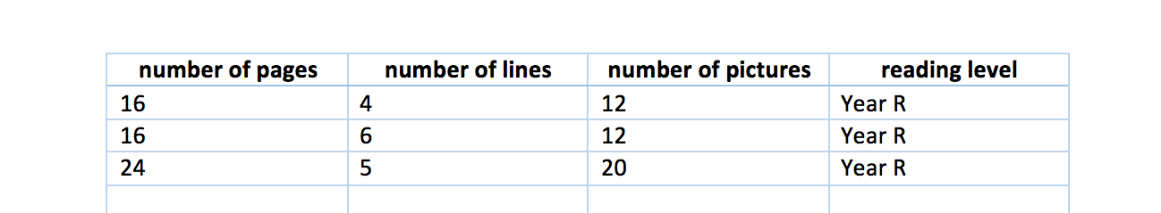*

1. 搜尋網頁：<https://machinelearningforkids.co.uk/>

Go to <https://machinelearningforkids.co.uk/> in a web browser

1. 點選“**Get started**”按鈕

Click on “**Get started**”

1. 點選“**Log In**”按鈕並登入系統

*如果你沒有帳號，請你的老師幫你建立一個帳號。*

*如果你不記得你的帳號或密碼，請你的老師幫你重新設定一次*

Click on “**Log In**” and type in your username and password  
*If you don’t have a username, ask your teacher or group leader to create one for you.  
If you can’t remember your username or password, ask your teacher or group leader to reset it for you.*

1. 點選上方清單中的 **”Projects”** 按鈕

Click on “**Projects**” on the top menu bar

1. 點選 “**+ Add a new project**” 按鈕

Click the **“+ Add a new project**” button.

1. 將你的專案命名為 “school library”並設定成辨識 “**numbers**”

類別

Name your project “school library” and set it to learn how to recognise “**numbers**”  
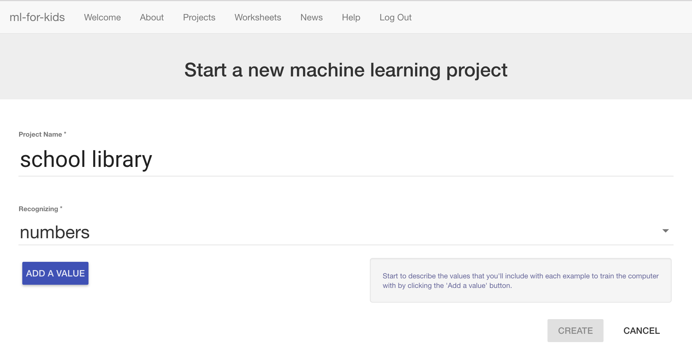

1. 點選三次“**Add a value**”按鈕，每個類別都選擇 “number”

Click “**Add a value**” three times.   
Set the type of all these values to “number”.   
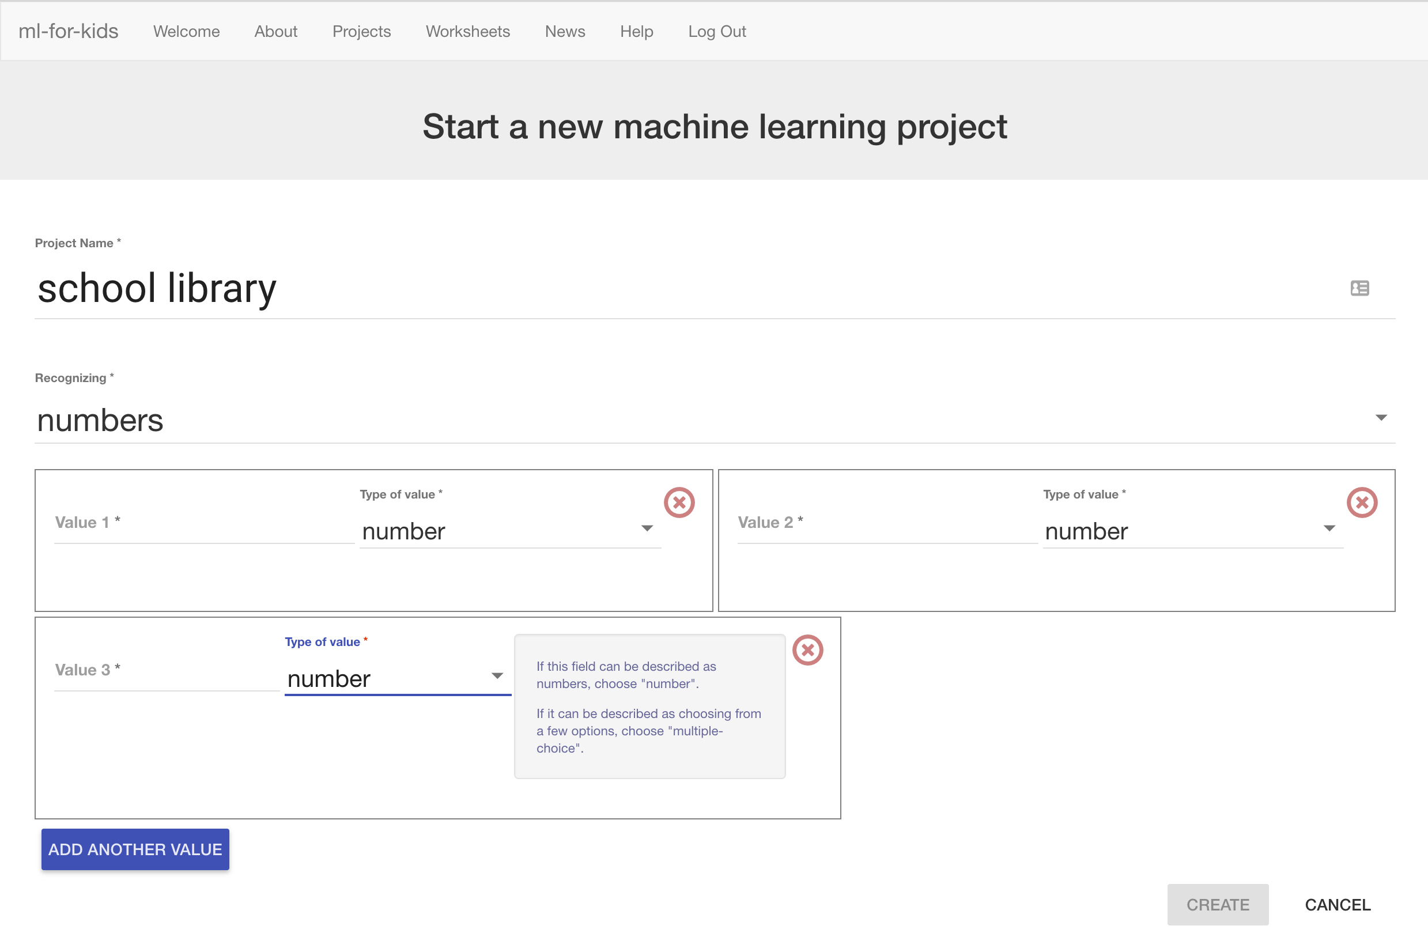

1. 將它們分別命名為：“pages”、 “lines”和“pictures”

*pages代表總頁數。*

*lines代表一頁的行數。*

*pictures代表圖片總數。*

Name the three fields “pages”, “lines” and “pictures”  
*We will use these for:  
pages – the number of pages in a book  
lines – the number of lines on a page  
pictures – the number of pictures in the book*  
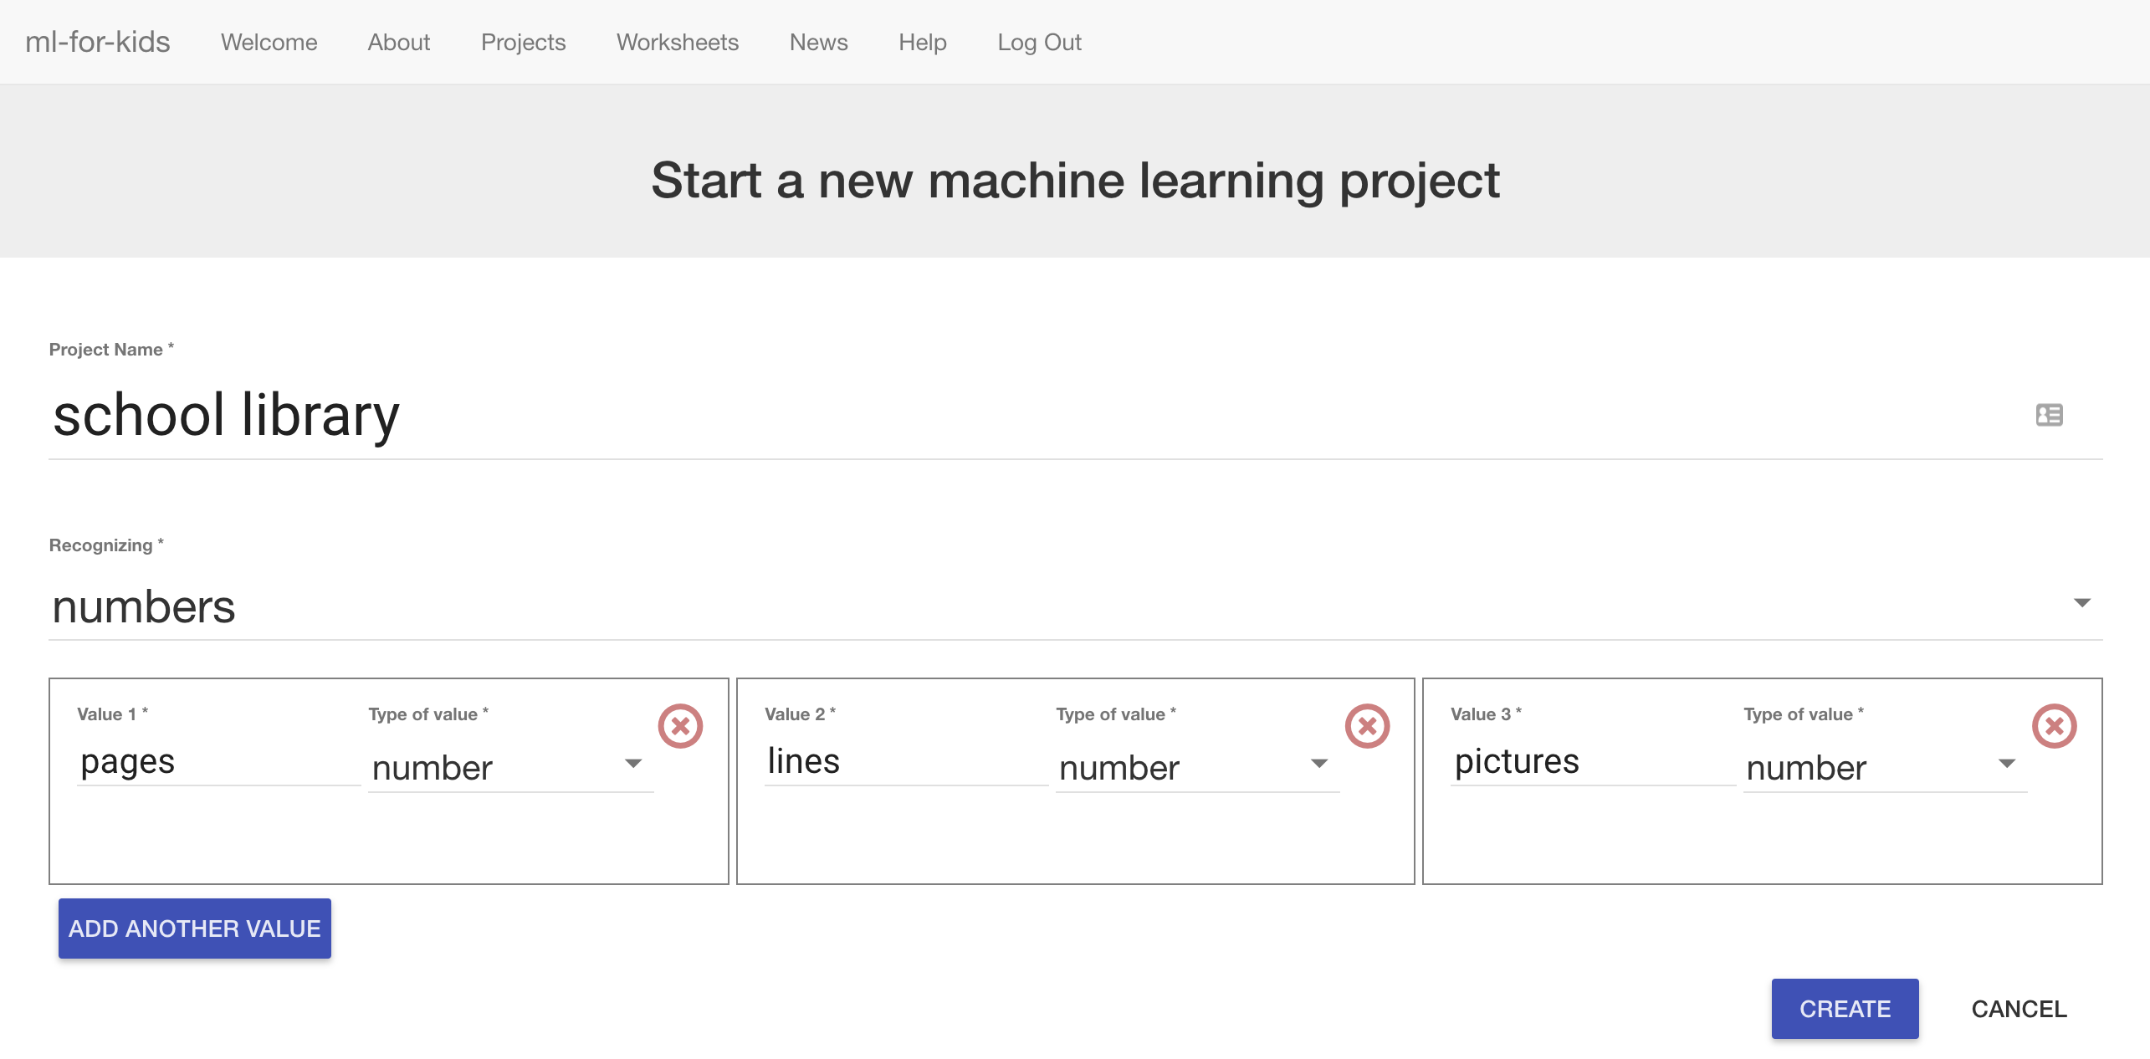

1. 點選“**Create**”按鈕，你會在專案清單中看到“school library”，點選此專案

Click “**Create**”  
“school library” should now be in your projects list. Click on it.   
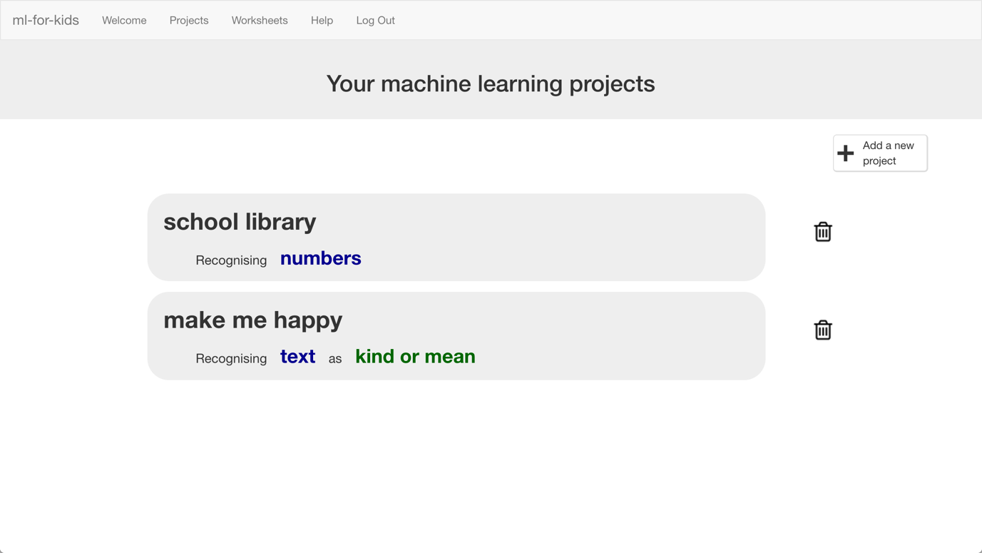

1. 點選 **”Train”** 按鈕，我們要開始蒐集訓練電腦用的範例書籍。

We’ll start by collecting examples of books to train the computer with. Click the **Train** button.  
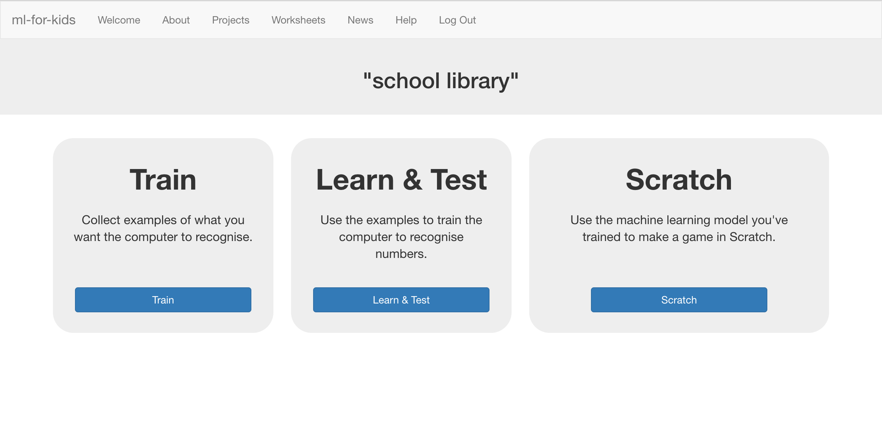

1. 點選 “**+ Add new label**”按鈕，建立一個叫“Year R”的方框，再建立兩個方框，分別命名為“Key Stage 1”和“Key Stage 2”。

*如果你不是用這三種級別，將方框名稱改成你使用的級別名稱*

Click on **“+ Add new label**” and call it “Year R”.   
Do that again, and create a second bucket called “Key Stage 1”.  
Do that again, and create a third bucket called “Key Stage 2”.  
*If you used different names for reading levels, use those instead.*   


1. 點選“Year R”方框中的“**Add example**”按鈕，輸入一本Year R級別書的資訊，點選“**Add**”按鈕。

Click the “**Add example**” button in the “Year R” bucket, and type in the values from your first Year R book. Click “**Add**”  
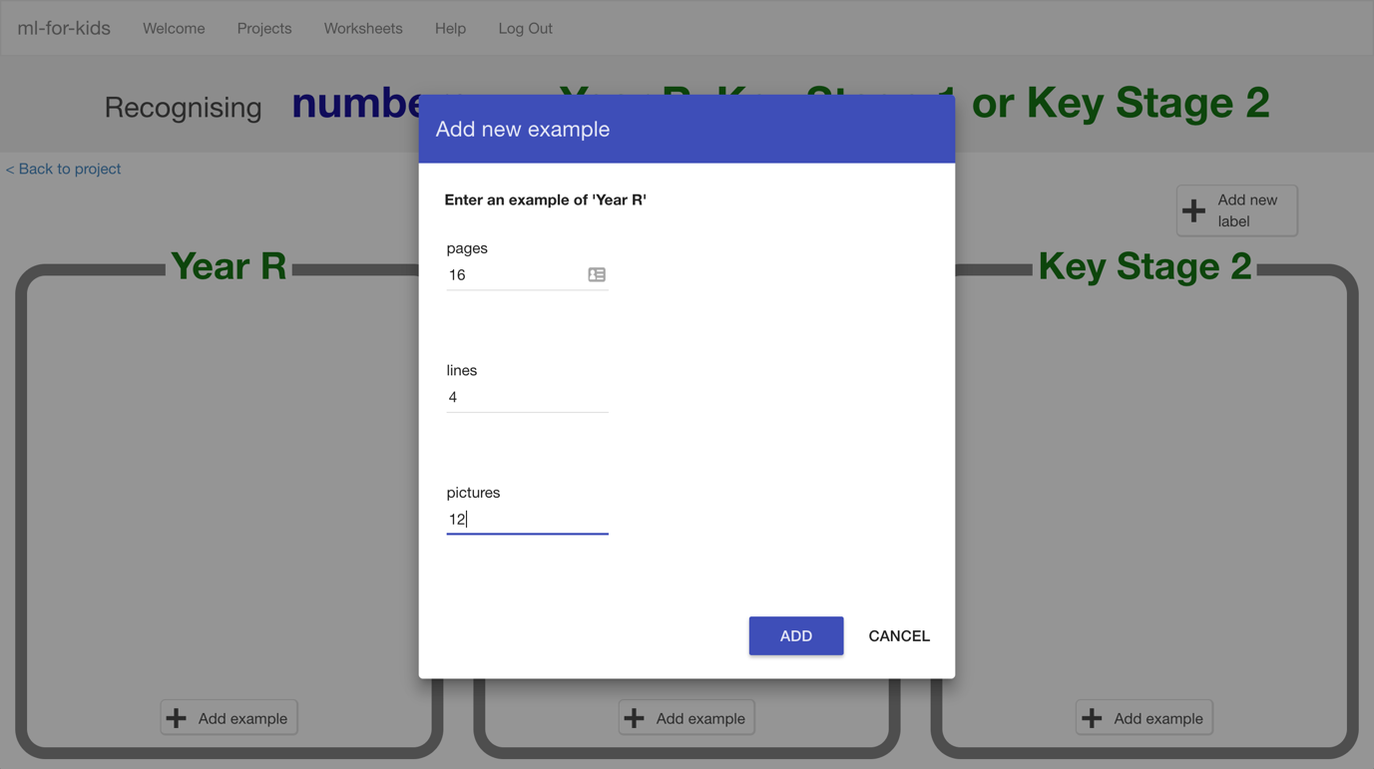

1. 輸入所有範例書籍的資訊。

Do this for the values of all the books you collected.  
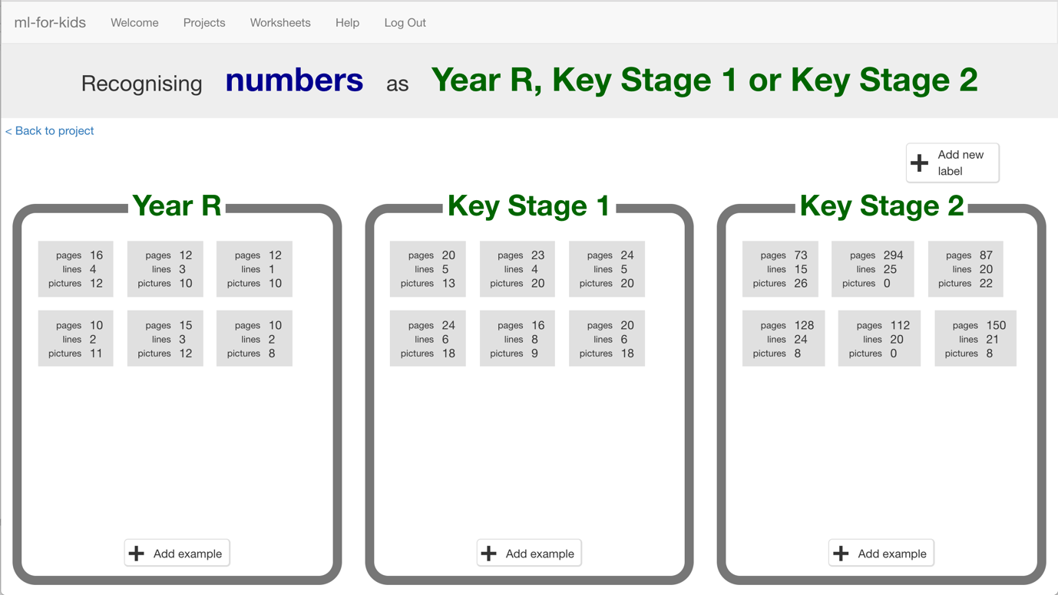

1. 輸入完畢，點選“**< Back to project**”，再點選**Learn & Test**

Click the **“< Back to project**” link once you’ve finished to go back to the Project menu, then click on the “**Learn & Test**” button.

1. 點選**Train new machine learning model**按鈕

Click the “**Train new machine learning model**” button at the bottom of the page.   
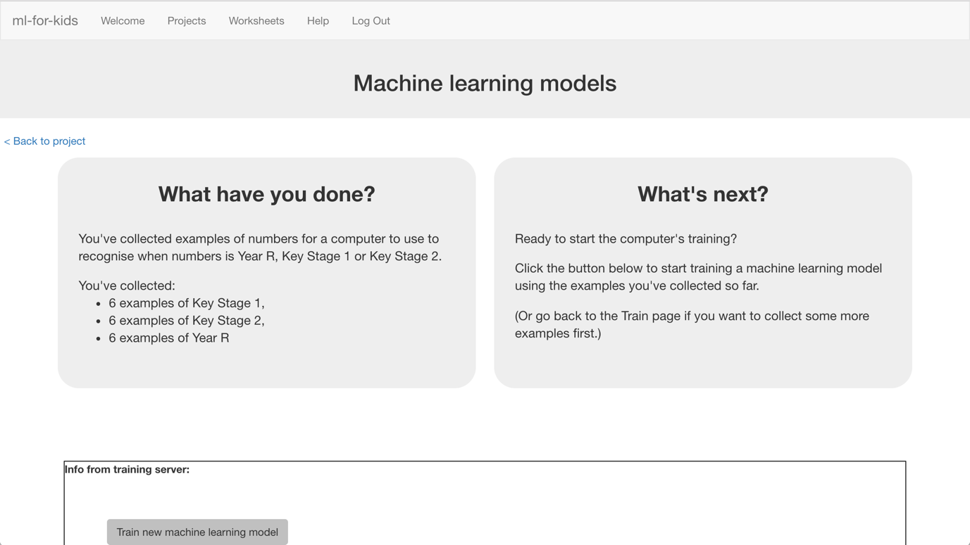

1. 當訓練完成後，會出現一個文字框，使用這個來測試模型。

*用一本電腦沒看過的書籍來測試。如果你對電腦的預測結果不滿意，回到步驟15，加入更多範例，並重複步驟18訓練一個新的模型！*

Use the Test form to try out the model you’ve trained.   
*Test it with a book that you haven’t shown the computer before. In other words, not one that you’ve used in your examples in Training.  
If you’re not happy with how the computer predicts the reading level, go back to step 15, and add some more examples.   
Make sure you repeat step 18 to train with the new examples though!*  
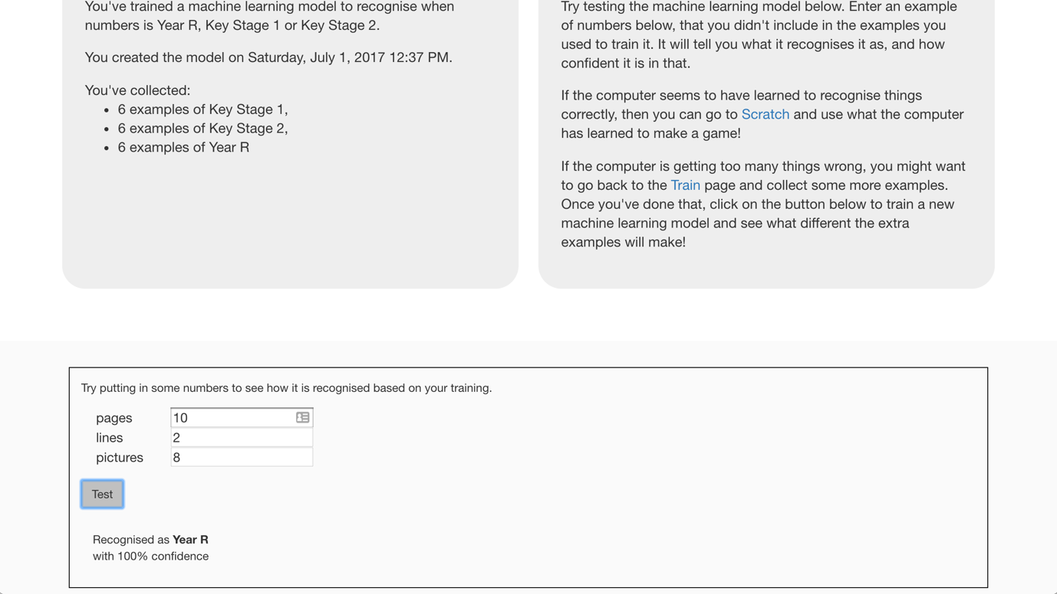

**到目前為止，你做了哪些事情？**

**What have we done so far?**

你開始訓練電腦判斷一本小說的閱讀難度。電腦會從書籍的各項數值將書分類成Year R、Key Stage 1或Key Stage 2。

You’ve started to train a computer to predict the reading level for a fiction book. You’ve done this by training it recognise sets of numbers as being “Year R”, “Key Stage 1”, or “Key Stage 2”.

蒐集來的範例被用來訓練一個機器學習『模型』。

These examples are being used to train a machine learning “model”.

這就是所謂的『監督式學習』，因為你在這個過程中確保（監督）電腦收到的結果是正確的 (supervised learning)。

This is called “supervised learning” because of the way you are supervising the computer’s training.

電腦會從範例學習到一些模式，並使用這些模式進行預測。

The computer will learn from patterns in the examples you’ve given it. These will be used to be able to make predictions for numbers about new books.

1. 點選“**< Back to project**”按鈕，再點選“**Scratch**”

Click the **“< Back to project**” link, then click the “**Scratch**” button.   
*This page has instructions on how to use the new blocks in Scratch from your project. Keep the page open if you need to check on how to use them.*

**小技巧**

**Tips**

**多一點範例！**

**More examples!**

當你給越多範例，電腦就應該能更正確的預測書本難度。

The more examples you give it, the better the computer should get at recognising the reading level for books.

**盡可能蒐集相同數量的範例**

**Try and be even**

嘗試讓各種閱讀級別的範例一樣多

Try and come up with roughly the same number of examples for each reading level.

如果你其中一種級別的範例特別多，那麼電腦可能會更容易將書判別成這一類，因此會影響到電腦的學習

If you have a lot of examples for one reading level, and not the others, the computer might learn that reading level is more common and more likely, so you’ll affect the predictions that it makes.

**確保有各種類型的範例**

**Mix things up with your examples**

試著蒐集不同類別的範例

Try to come up with lots of different types of examples.

舉例來說，不要在同一級別中採用太過相似的書籍當作範例

For example, don’t choose lots of examples of very similar books in a set or series.

1. 點選“**Open in Scratch**”，開啟scratch

Click the “**Open in Scratch**” button at the bottom to launch the Scratch editor.   
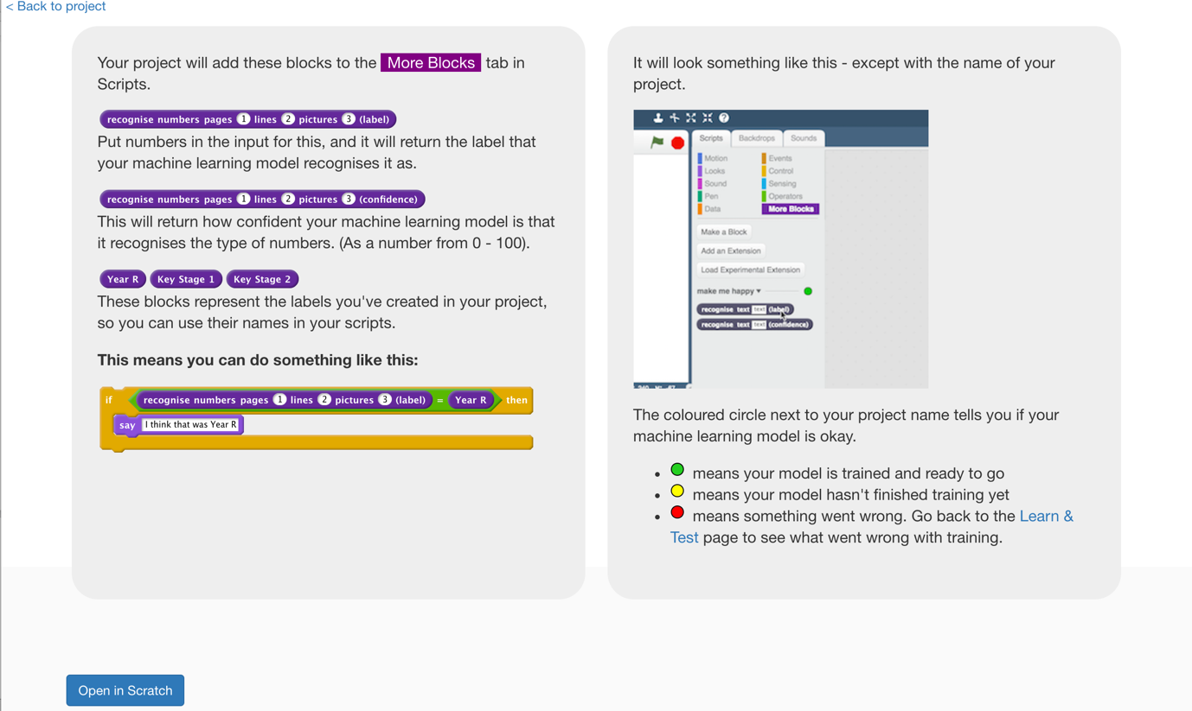

1. 你可以在專案裡的『更多積木』(More blocks)區看到新積木

You should see new blocks in the “More blocks” section from your “school library” project.  
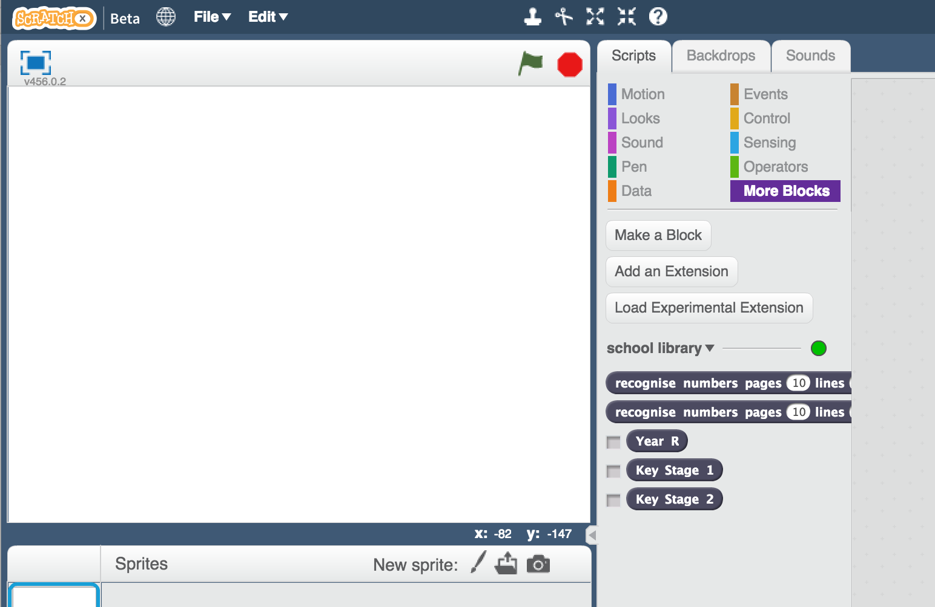

1. 幫每個角色新增三個變數，分別命名為：number of lines、number of pages和number of pictures，並設定成『顯示』，才能在舞台畫面看到這些變數。

Create three new variables, for all sprites. Call these “number of lines”, “number of pages”, and “number of pictures”.  
*Leave them ticked, so they stay visible on the stage.*  


1. 設定所有變數的顯示方式為『滑桿』，並稍微調整變數位置

*在舞台上的變數按右鍵，選擇『滑桿』*

Set all of the variables so that they are displayed on the stage as “sliders”. Spread them out a bit so you have space.  
*Right click on the variables on the stage, and choose “slider”.   
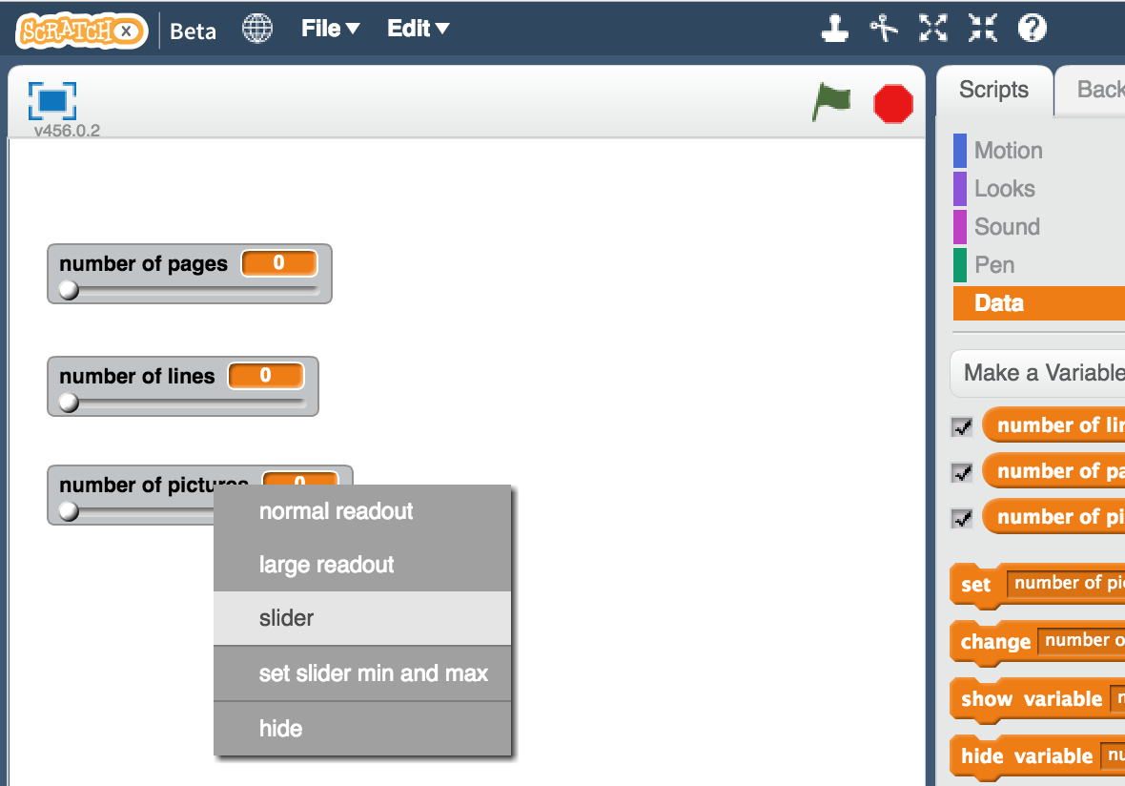*

1. 設定每個滑桿的最大與最小值

*舉例來說，你可以把pages最小值設為0，並把最大值設為300。number of lines的範圍設成0-40，pictures的範圍設成0-50。*

*不過每個變數的範圍數值仍須依照你所選的書籍做調整。*

Update the minimum and maximum for each of the sliders so that the range is more sensible.   
*For example, you could use minimum of 0 and maximum of 300 for pages.   
You could use 0 – 40 for number of lines.  
You could use 0 – 50 for pictures.   
But choose what you think makes sense based on your books.*  
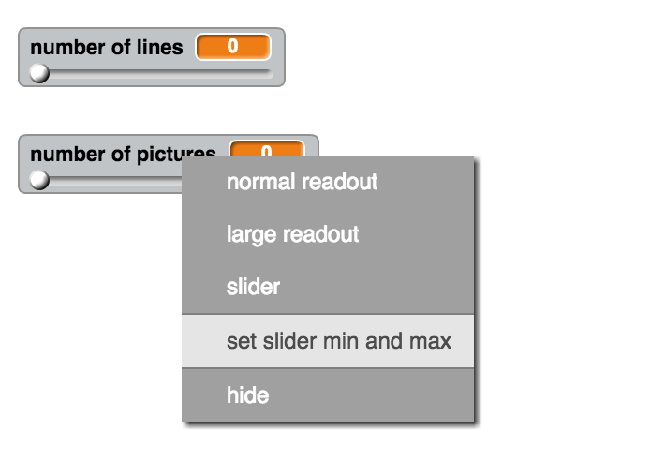

1. 點選畫筆，要畫出一個新的角色

Create a new sprite by clicking on the paint brush button next to the “New sprite” label.   


1. 畫出一個上面有Recommend字樣的按鈕。移動按鈕到三個變數下方並調整大小。

Draw a button and give it a label like “Recommend”.   
*Move it to under your three sliders, and adjust the size so that it fits.*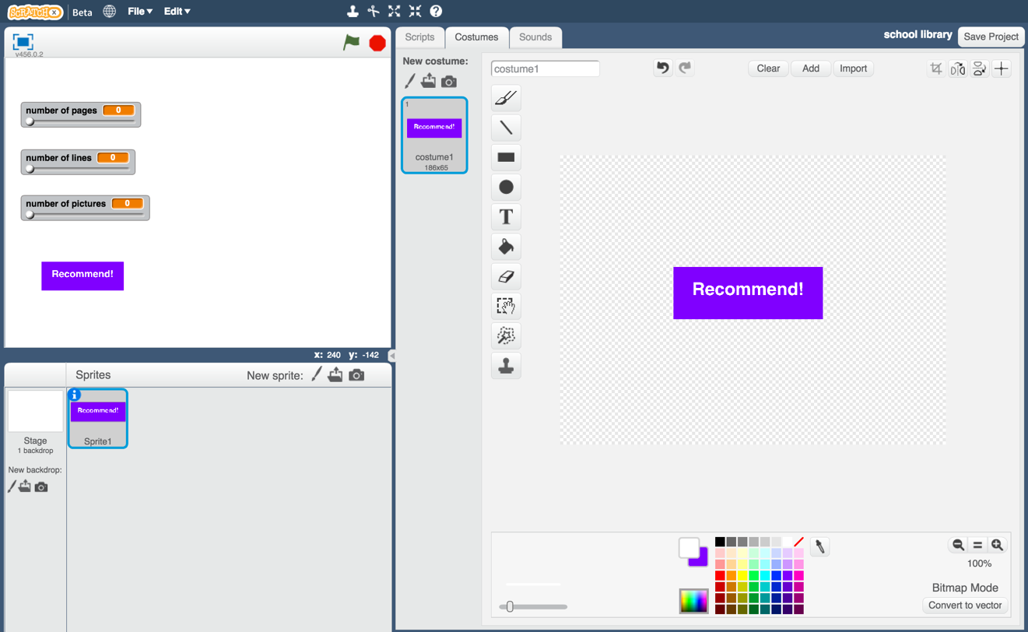

1. 點選『程式』

Click on the Scripts tab.

1. 拖曳程式積木（如下圖），如此一來，當按鈕被按下時會廣播一個recommend訊息。

Create a script for this button sprite, so that clicking the button broadcasts a new “recommend” message.  
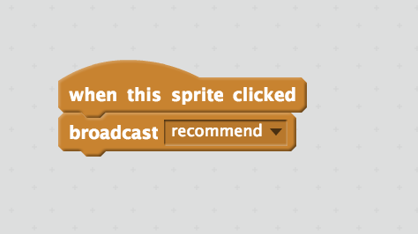

1. 點選畫筆，我們要再畫出另一個角色

Click on the “Paint new sprite” paintbrush icon again, to create another sprite.

1. 將角色命名為：reading level

*點擊角色旁的藍色i按鈕來新增角色名稱*

Name the sprite “reading level”  
*Click on the blue* ***i*** *icon shown below to name the sprite*  


1. 替角色reading level新增三個造型

*點選『造型』下的畫筆按鈕以新增造型*

Create three costumes for the reading level sprite.  
*Click on the paint brush button next to the “New costume” label to do this.*   


1. 將造型分別命名為：Year R、Key Stage 1和Key Stage 2

Name the costumes “Year R”, “Key Stage 1”, and “Key Stage 2”  
*Type the names into the white box shown below*  
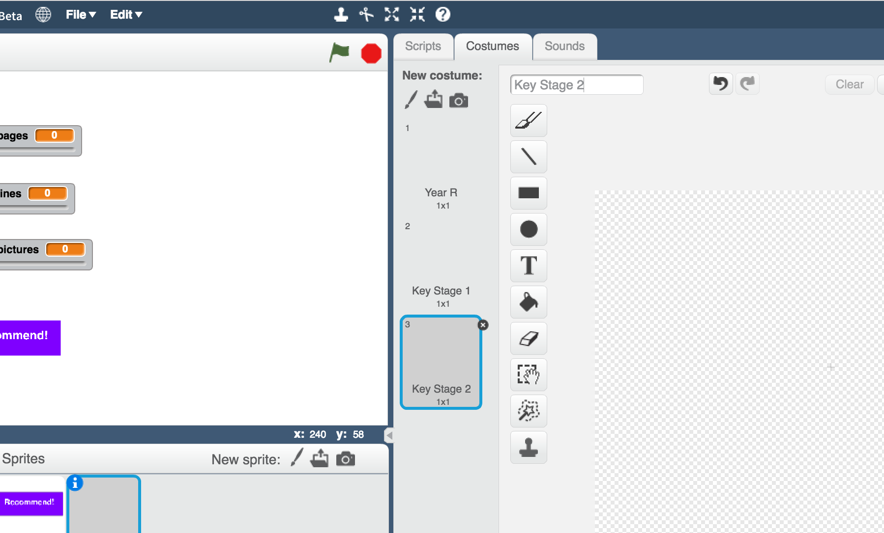

1. 在每個造型中畫一個小朋友

*Year R畫一個小小孩，Key Stage 1畫一個稍微大一點的小孩，而Key Stage 2畫一個更大的小孩。*

*如果你不太會畫畫，也可以用圖片代替！*

Draw a child in each costume.   
*Draw a small child in the Year R costume  
Draw a medium child in the Key Stage 1 costume  
Draw a larger child in the Key Stage 2 costume  
If you’re not good at drawing, a stick figure is fine!  
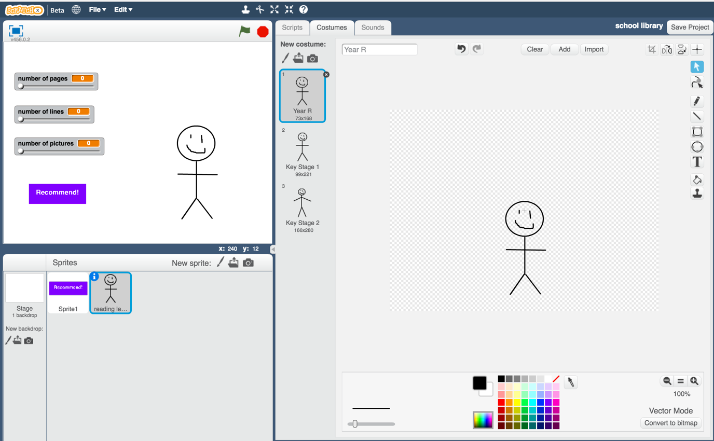*

1. 點選『程式』，拖曳程式積木（如下圖）

*如果想要縮短時間，可以試試『複製』程式積木*

Click on the Scripts tab and enter the following script.  
*Think about how you could use “Duplicate” to make this easier.*  
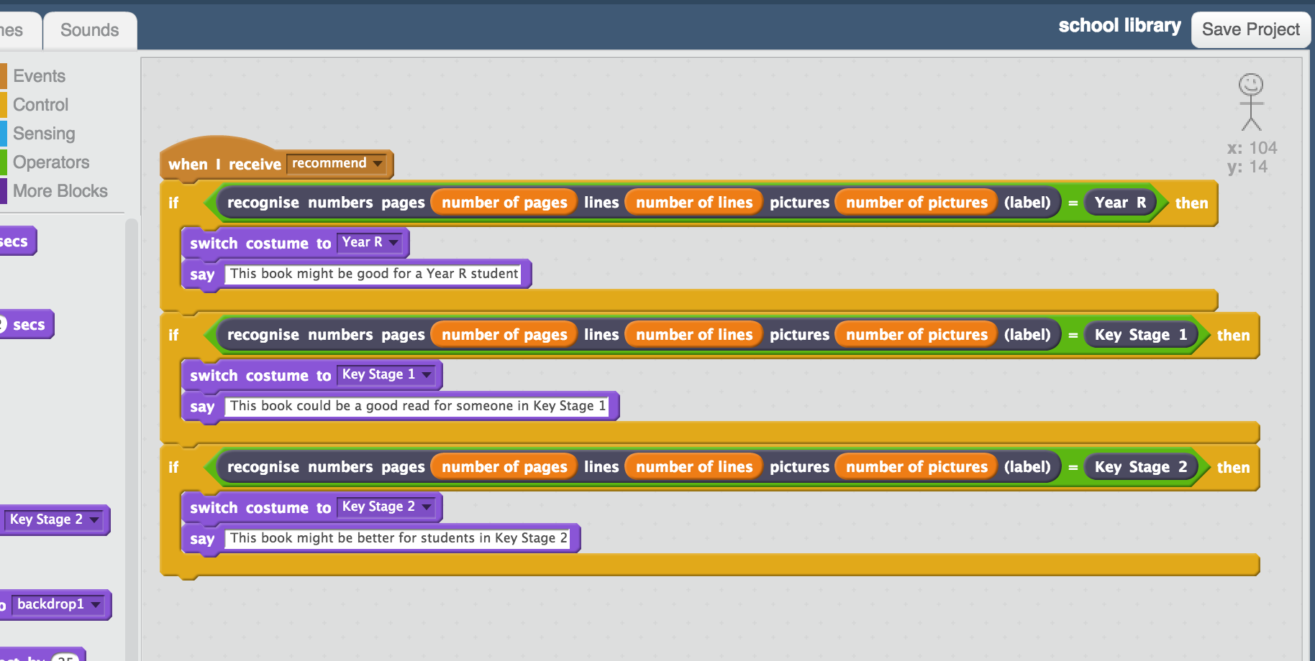

1. 開始測試專案！

*選一本沒有用在訓練模型的書，依照這本書設定每個變數的值。點擊recommend按鈕看電腦建議這本書適合誰。*

Test your project!  
*Set the sliders to values from a new book – a book that you didn’t use to train your machine learning model.   
Click the recommend button to see a recommendation for who the book is suitable for.*  
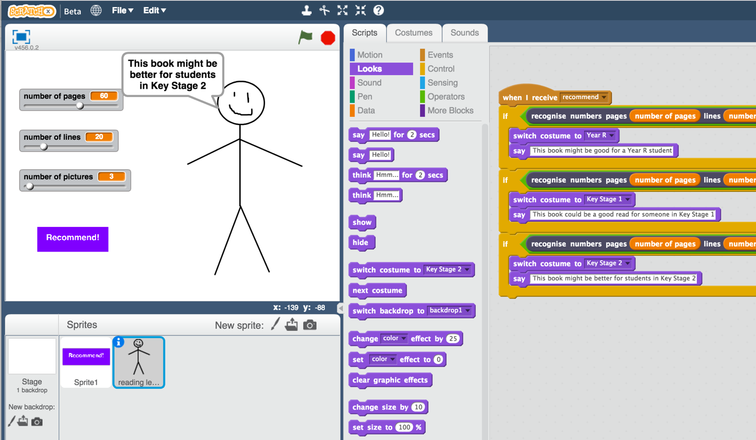

1. 存檔

*點選檔案，再點選儲存專案*

Save your project  
*Click File -> Save Project*

**你完成了什麼？**

**What have we done so far?**

你使用機器學習創造了一個Scratch版的圖書館管理員

You’ve created a Scratch game with a school librarian that uses machine learning.

角色使用預測建模(predictive modelling)：基於訓練出來的機器學習模型預測一本書適合誰閱讀。

Your character is using “predictive modelling” – making a prediction of who a book might be suitable for, based on the machine learning model that you’ve made.

你蒐集一些範例書籍並告訴電腦這些書的難度級別，以此訓練機器學習模型。當給的範例越多，電腦可以預測的更準。

You trained that machine learning model by collecting examples of books, and telling the computer what reading level each of them would be. The more examples you give it, the better it should get at recommending correctly.

**延伸活動**

**Ideas and Extensions**

現在你已經完成了這個專案，要不要試試下面的點子？或者，自己想一個？

Now that you’ve finished, why not give one of these ideas a try?

Or come up with one of your own?

**選擇不同數值**

**Choose different numbers**

除了總頁數、一頁的行數以及圖片數外，還有什麼數值可以使用呢？你能蒐集到哪些可以用來預測的數值？書本厚度？字體大小？

Instead of number of pages, number of lines, and number of pictures, what other numbers could you use?

What other numbers or measurements could you make that you think could be used to make predictions or recommendations?

The height of the book? The thickness? The size of the letters?

試著使用你自己想出來的點子做一個新的專案，然後跟這個專案比較，看誰的預測結果比較正確。

Try creating a new numbers project and this time use your own ideas. Compare it with your first project – is it better or worse at making recommendations?